TITLE OF THE PAPER TO BE PRESENTED

AT THE 2020 CONTART CONFERENCE

**\*\*\* NOT INCLUDE AUTHORS NEITHER FILIATION \*\*\***

**KEYWORDS**: Identify the main topic or the subject matter within the area of knowledge to which the study belongs. Arrange the words in order of the most general themes to more specific themes, separating them using “;”. The number must be no greater than four.

ABSTRACT

These instructions describe the requirements for the format of the papers to be sent to the 2020 CONTART Conference “THE BUILDING CONVENTION”. It contains information about letter formats, sizes and fonts, how to structure the different sections of the paper, and how to present tables, figures and bibliographical references. The abstract cannot take up more than this first page, without exceeding 500 words, and must not contain acronyms, references, equations, figures or tables. The abstract summarises the conclusions of the paper, as well as the methods used, and should not be considered to be part of the paper's introduction. **This model paper has been written using the compulsory paper size, margins, font and size of letter, and therefore writing the paper on it is recommended.**

# INTRODUCTION

This document provides information and instructions about preparing papers for the 2020 CONTART Conference “THE BUILDING CONVENTION” It is important to respect the specified style to the utmost, in order for the proceedings of the Conference to maintain a consistent appearance. You can use this pre-established format as a guide to draft your paper (A4 paper, with 2.5cm left, right, upper and lower margins, the font Times New Roman 11pt, and lines with simple spacing). Do not change the type and size of the font, the spacing, the page margins, the page header/footer and the general structure of the document. The first page must include the title, the name and contact details of the authors, keywords and the abstract. **If the paper is not sent in accordance with these instructions, it may be rejected**.

The Organising Committee will accept for review scientific papers submitted presenting advances in the state of knowledge and papers on technological development with innovations and work of practical interest resulting from specific applications with regard to the topics of the Conference.

Papers must be written in Spanish or English, preferably utilising the MS Word® word processor, and using the International System of Units (S.I.).

# PAPERS

## Text

The text must be written in a single column with simple spacing, and must be justified. Use the Times New Roman font or its equivalent. The font size to be used is 11 points. When starting a paragraph, leave one extra line blank (a space). Do not use indents.

The abstract must be located on the first page of the paper. The first point of the paper must be **“Introduction”.**

## Length

The paper must have a maximum length of 8 pages, and follow the structure of ABSTRACT, INTRODUCTION, DEVELOPMENT/METHODOLOGY, RESULTS AND DISCUSSION, CONCLUSIONS, ACKNOWLEDGEMENTS, BIBLIOGRAPHICAL REFERENCES AND NOMENCLATURE (where applicable).

## Title of the paper and authors

On the first page of the paper, write the title, the names of the authors, and their affiliations and email addresses. Write the Centred title using Times New Roman 12pt in bold type, in uppercase letters only and with simple spacing. Leave two lines (12pt size) blank between the title and the authors' names. The title of the paper should not exceed 120 characters, counting spaces.

Each author must be appropriately identified with superscript. Write the names of the authors. Write first the surname and then first name, and place it Centred under the title. In the case of compound names, use initials for the rest followed by “.”. Use Times New Roman 12pt in bold type, with uppercase and lowercase letters. Leave one line (10pt size) blank between the authors' names and their affiliations. Write the affiliations and their addresses. Include their email address. Use Times New Roman 10pt.

## Abstract and keywords

The heading KEYWORDS must be written in Times New Roman 11pt, in bold type and uppercase letters. After the heading KEYWORDS, write a maximum of four words relating to the main topic of the paper. Leave an empty line (11pt size) between the KEYWORDS and the ABSTRACT.

The heading ABSTRACT must be written in Times New Roman font, 11pt, in bold type and uppercase letters. Leave a line (11pt size) blank between the heading and the text. Write the summary using the 11pt font size. Leave a line (11pt size) blank between the ABSTRACT and the INTRODUCTION.

## Titles and subtitles

Titles must be written in **uppercase** and bold type, using Times New Roman 11pt. One line (11pt size) must be left blank both above and below the main heading. Main headings must be numbered; use whole numbers in ascending order for this purpose.

One title can have several subtitles. Subtitles are written in **lowercase** and are identified through two digits: the first is the number of the title and the second is the consecutive number of the subtitle. Subtitles are written in bold type, using 11pt font size. They must be placed on the left-hand side of the page (as shown in this template) and one line (11pt size) must be left blank both above and below the secondary heading.

# EQUATIONS

To write equations in the text, use Microsoft Equation Editor or MathType. Equations must be Centred, and one line (11pt size) must be left blank both above and below them. Number them in consecutive order. Make sure that the symbols in your equation have been defined before the equation appears or immediately afterwards. Symbols must appear in italics.

*E = mc*2  (1)

As shown in (1), put the number of the equation inside round brackets and locate it to the right of the page (as shown in this template). When an equation is referred to in the text, write (1).

# TABLES AND FIGURES (IMAGES AND PHOTOGRAPHS)

Figures and tables which are part of the paper must be integrated into the file, in the corresponding place inside the text.

Each table or figure in the text must be referenced. Number tables and figures separately and consecutively; for example, Figure 1, Figure 2, Table 1 and Table 2. You must use “Figure #” to refer to it in the text.

Write the title of the tables above the tables and Centre the title as shown in Table 1 (use Times New Roman 10pt font), with 6pt upper and lower spacing. Write figure titles below the figures as shown in Figure 1 (use Times New Roman 10pt font), with 6pt upper and lower spacing.

Make sure that the tables and figures are clearly legible. **Do not place borders around figures**. Leave one line (11pt size) blank both above and below tables or figures.

Tables and figures must be designed so they are visible, matching the format of 160mm (width of text on the page), with good contrast so that quality is not lost when reduced, at a minimum resolution of 300dpi. Low quality images will not be accepted (photocopies of illustrations etc.). All tables and figures will be published in Black and White and therefore must be included by the authors of the paper in **black and white**.

The sources of any tables, figures and photographs which are not by the author must be cited.

Any abbreviations used in the graphics and tables and their source will be explained inside the tables or figures themselves.

Examples are given below of a table and a figure.

Table 1: Title of the table.

|  |  |
| --- | --- |
|  |  |
| 1 | 120 |
| 4 | 555 |
| 5 | 100 |
| =sample; =datum | |



= tension; =deformation

Figure 1: Title of the figure

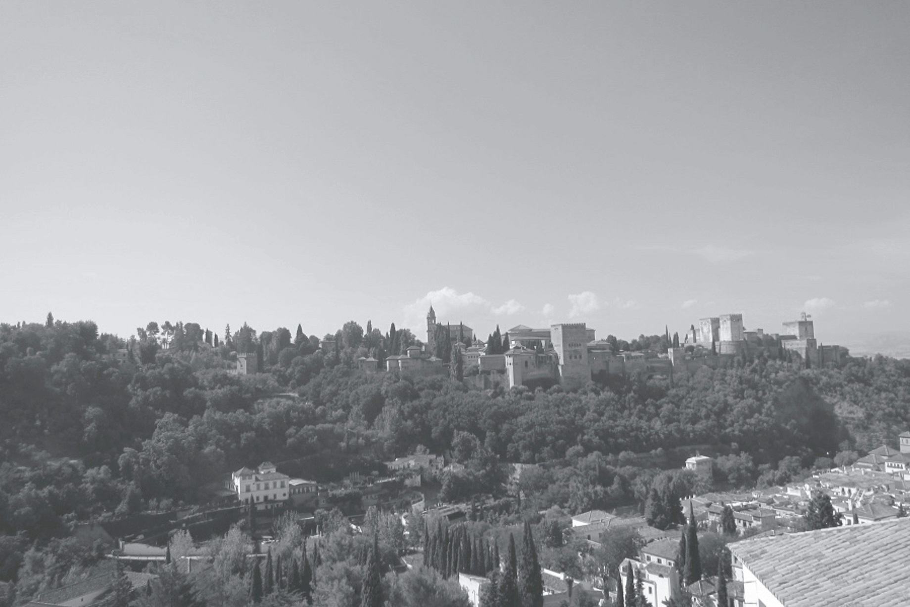

Figure 2: Title of the figure.

# ABBREVIATIONS AND ACRONYMS

Define any abbreviations and acronyms which are not common as soon as they appear in the text, even if they were defined in the abstract. It is not necessary to define commonly used abbreviations. Do not use abbreviations in the title unless unavoidable.

# CONCLUSIONS

Final conclusions must compulsorily be presented in the paper.

# BIBLIOGRAPHICAL REFERENCES (AND CITATIONS IN THE TEXT)

References are important for the reader; therefore, each citation must be complete and correct.

The reference numbers of the citations are included in the text. References must be numbered consecutively, in the order they appear and inside square brackets [1]. In the text, simply cite the reference number; for example, as in [2].

When text is quoted, it must be added into the main text between inverted commas (“text of the quote”) and the source must be indicated as has been explained above.

Bibliographical references must refer only to those cited in the paper and must be given in strict numerical order. The authors are responsible for the accuracy of their references.

The international standards generally used in different publications will be followed. Examples are given below depending on the location where the source was consulted:

*Examples taken from:*

[*http://www.ort.edu.uy/ie/pdf/ejemplosdecitacionapa.pdf*](http://www.ort.edu.uy/ie/pdf/ejemplosdecitacionapa.pdf)

[*http://www.library.dal.ca/Files/How_do_I/pdf/apa_style6.pdf*](http://www.library.dal.ca/Files/How_do_I/pdf/apa_style6.pdf)

Leave one line (11pt) blank between each reference.

IN A JOURNAL

[1] Keller, T. E., Cusick, G. R., &Courtney, M. E. (2007). Employee engagement: Improving participation in safety. *Professional Safety, 53*(12), 40-45.

IN A NEWSPAPER

[2] Generic Prozac debuts. (2001, August 3). *The Washington Post,* pp. E1, E4.

ARTICLE WITH A DOI ASSIGNED TO IT

[3] Whitmeyer, J. M. (2000). Power through appointment. Social Science Research, 29(4), 535-555.doi:10.1006/_ssre.2000.0680

IN AN E-JOURNAL (NON-PRINTED VERSION)

[4] Ashe, D. D., & McCutcheon, L. E. (2001). Shyness, loneliness, and attitude toward celebrities. Current Research in Social Psychology, 6(9). Retrieved from

<http://www.uiowa.edu/~grpproc/crisp/crisp.6.9.htm>

WITHOUT DOI (includes URL of the journal's web page)

[5] Boutsen, F., Cannito, M. P., Taylor, M., & Bender, B. (2002). Botox treatment in adductor spasmodicdysphonia: A meta-analysis. Journal of Speech, Language, and Hearing Research, 45, 469-481.Retrievedfrom<http://jslhr.asha.org/>

PAPER AT THE PRINTING STAGE

[6] Turney, P.D. (in press). The latent relation mapping engine: Algorithm and experiments. Journal of Artificial Intelligence Research. Retrieved from <http://cogprints.org/6305/1/NRC-50738.pdf>

BOOK

[7] Frank, R. H., & Bernanke, B. (2007). *Principles of macro-economics* (3rd ed.). Boston, MA: McGraw-Hill/Irwin.

UNDATED BOOK

[8] Smith, J. (n.d.). *Morality in masquerade*. London: Churchill.

BOOK WITHOUT AUTHOR

[9] Experimental psychology. (1938). New York: Holt.

BOOK WITH EDITOR WITHOUT AUTHOR

[9] Gibbs, J. T., & Huang, L. N. (Eds.). (2001). *Children of color: Psychological interventions with culturally diverse youth*. San Francisco, CA: Jossey-Bass.

BOOK CHAPTER

[10] Hammond, K. R., & Adelman, L. (1986). Science, values, and human judgment. In H. R. Arkes & K. R. Hammond (Eds.), *Judgement and decision making: An interdisciplinary reader* (pp. 127-143). Cambridge, England: Cambridge University Press.

THESES

[11] Carlson, W. R. (1977). Dialectic and rhetoric in Pierre Bayle. (Unpublished thesis). Yale University, USA.

SPEECH IN CONFERENCE PROCEEDINGS

[12] Benfica, J., Bolzani, L., Vargas, F., Lipovetzky, J., Lutenberg, A., García, S., Gatti, E., Hernandez, F., & Vilar, N. (2011). *Evaluating the use of a platform for combined tests of total ionizing dose radiation and electromagnetic immunity*. In Proceedings of the European Conference on Radiation and its Effects on Components and Systems (RADECS) (pp. 473-178). Sevilla: Institute of Electrical and Electronics Engineers.

PUBLICATION IN CD

[13] Reporter, M. (1996, April 13). Electronic citing guidelines needed [CD-ROM]. New York Times, (late ed.), p. c1. Retrieved from New York Times Ondisc.

WEB PAGES AND OTHER RESOURCES TAKEN FROM THE INTERNET

WEB PAGE

[14] Kidpsych is an excellent website for young children. Accessed April 4, 2012, from http://www.kidpsych.org.

ONLINE BOOK

[15] Bryant, P. (1999). *Biodiversity and Conservation*. Accessed August 21, 2012 from http://darwin.bio.uci.edu/~sustain/bio65/Titlpage.htm

JOURNAL TAKEN FROM THE INTERNET

[16] Koo, D. J., Chitwoode, D. D., & Sanchez, J. (2008). Violent victimization and the routine activities/lifestyle of active drug users. *Journal of Drug Issues, 38,* 1105-1137.

Accessed April 4, 2012, from http://www2.criminology.fsu.edu/~jdi/.

BLOG

[17] MiddleKid. (2007, January 22). The unfortunate prerequisites and consequences of partitioning your mind [Web log message]. Retrieved from

<http://scienceblogs.com/pharyngula/2007/01/the_unfortunate_prerequisites.php>